Role Profile Part 1

Role title | NaVCIS Field Intelligence Officer | Grade/Rank | DC/PC
Dept/Area | NaVCIS | Vetting Level | RV
Responsible to | NaVCIS Intelligence Manager | Staff line managed | N/A
Reviewed by (Line Manager) | Stuart Bell | Date | 01.07.25
Purpose of Job | To be responsible for identifying, collecting and developing intelligence for the business area. Ensure they focus on the priorities in tackling crime and protecting people from harm. They will assist in tackling organised crime groups (OCG’s) and exploit all opportunities to tackle vehicle crime and poly-criminality. To utilise intelligence to identify current and future threats posed nationally.
Key Accountabilities | 1.) To identify, evaluate, manage & develop intelligence ethically and effectively in line with the National Intelligence Model, developing intelligence for NaVCIS business area priorities and national threats.  2) To assist regional, national and international Law enforcement agencies with intelligence and evidence support using a variety of intelligence methods and operational activities.  3) To work in partnership with private industry, act as a single point of contact with NaVCIS stakeholder partners and work closely with NaVCIS consultants and other ports based Officers to enable resilience and role support.  4) To maintain, utilise and expand a substantial national and international network of contacts  5) Provide resilience to NaVCIS core business and related portfolios such as investigating allegations of vehicle finance theft and fraud referred by Finance & Leasing Association members.  6) Prepare and deliver at all levels high quality intelligence files and reports for submission to law enforcement agencies and evidence for criminal prosecution processes and represent all Field Intelligence Officer functions including briefing, presentation, enforcement and prevention functions.  7) Have an excellent awareness of CPIA, Fraud Act 2006, Theft Act 1968, Data Protection principles, ECHR, RIPA, CHIS code of practise, NIM, covert tactics and ensure the principles are adhered to.  8) Contribute towards the identification of Organised Crime trends in order to develop innovative intelligence lead and proactive solutions using NaVCIS resources and negotiation of law enforcement support.  9) To give regular and effective service.  Note: This role profile is designed to assist post holders with understanding what is expected of them in their role. NaVCIS may ask them to undertake other duties, as required, which are not necessarily specified on the role profile but which are commensurate with the grade of the post. The role profile itself may be amended from time to time within the scope and general level of responsibility attached to the post.  NaVCIS is hosted by The Chief Constable of Hampshire and Isle of Wight Constabulary (HIOWC). NaVCIS staff are employed as police staff under HIOWC terms and conditions with supplementary NaVCIS procedures and guidance.
Additional Requirements | Follow GDPR guidelines and Constabulary policies in relation to accessing and handling personal data.  All officers and staff must be aware of risk in relation to their role, please view the appropriate Health & Safety Risk Assessment for the role.  The role holder may be required to visit various locations either within the UK or overseas. This may involve staying away from home. The role holder must be able to meet travel requirements so therefore possess a valid passport for travel outside of the UK and have access to a reliable system of transport where required.  NaVCIS is located at the College of Policing, Ryton.  There may be a requirement to work unsocial hours occasionally in order to respond to operational demands for which the appropriate recompense will be paid.  All role holders will need to undergo and maintain appropriate vetting in order to carry out the full duties of the role.  There is a requirement to wear a uniform (supplied) at all times whilst on duty.  All role holders will be expected to attend and successfully complete various in-house and national courses and any other role specific training as required to maintain a professional development portfolio. Role specific training for this role profile includes becoming a qualified vehicle examiner.

Role Profile Part 2

CVF Recruitment Competencies and Level | We are Emotionally Aware Level 1  We Take Ownership Level 1  We are collaborative Level 1  We Deliver, Support and Inspire Level 1  We Analyse Critically Level 1  We are Innovative and Open Minded Level 1  Integrity  Impartiality  Public Service  Transparency
Education/Qualifications | Essential:  - Competent Constable  - Full UK driving licence  Desirable  - Qualified vehicle examiner
Experience and Skills | Essential: N/S
Approved by People Services | Kat Stypulkowski | Date | 01.07.25

Role Profile Part 3

Competencies | All roles are expected to know, understand and act within the ethics and values of the Police Service.
Competencies | We are Emotionally Aware | Level 1 | 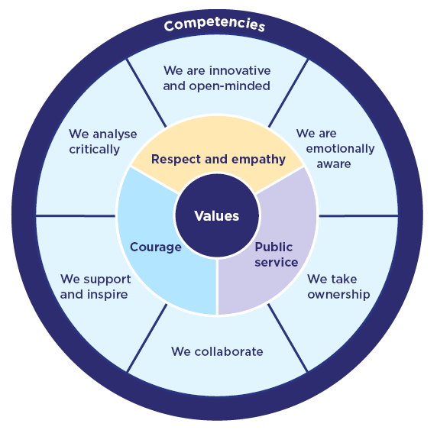
Competencies | We Take Ownership | Level 1
Competencies | We Collaborate | Level 1
Competencies | We Support and Inspire | Level 1
Competencies | We Analyse Critically | Level 1
Competencies | We are Innovative and Open Minded | Level 1
Underpinning Values | Courage
Underpinning Values | Respect and Empathy
Underpinning Values | Public Service
Initial Development Skills for new to role period | All staff are required to complete mandatory e-learning including annual DSE and Fire Safety plus any role-specific training required
Continuing Professional Development | Courses and Conferences should be attended to benefit professional learning and development.

